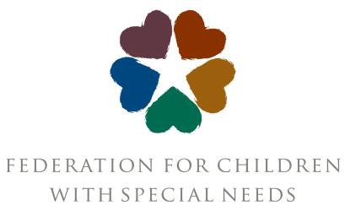

FCSN Board Member Responsibilities

General
- Support the organization’s vision, mission, values and goals.
- Hire, evaluate and support the executive director.
- Offer expertise to help ensure the health and success of the organization.
- Act as an ambassador for the organization. Work with the rest of the team to communicate the organization’s role to our most important audiences and to personal networks.

Meetings and Events
- Attend, to the extent possible, all board and relevant committee meetings.
- Attend organizational functions as appropriate.
- Review agenda and supporting materials prior to board and committee meetings.
- Serve on committees or tasks forces and offer to take on special assignments.

Governance
- Help to strategically grow the board by identifying, cultivating, and recruiting prospective board members with the experience, access, and leadership needed to drive the Federation for Children with Special Needs’ future success,
- Participate in creating an inclusive board environment that fully harnesses the benefits of a diverse board.

Financial
- Make personal financial contributions at the level that is generous for you and participate in the Federation’s fundraising and public visibility efforts as you are able.
- Assist the board in carrying out its fiduciary responsibilities, such as reviewing the organization’s annual financial statements.

Time Commitments
- The board holds 4-6 in-person meetings a year. These meetings typically last 2 hours.
- The board is asked to attend the Federation’s annual Visions of Community Conference (March) and Gala (September).
- Board members are asked to serve on at least one board committee.
- Board members are asked to attend special events.

Board Committees

- Finance Committee: Review and analyze financial reports, share observations and trends, and review investments. Also review the annual budget before presentation to the Board of Directors.
- Membership Committee: Identify needs for the board of directors, identify and interview new board candidates, shepherd board candidacies from beginning to end.
- Development Committee: Review Development/Fundraising activities, including working with staff to establish a fundraising plan, supporting efforts to raise money, being responsible for involvement of all board members in fundraising, and monitoring fundraising efforts to be sure that ethical practices are in place and that fundraising efforts are cost-effective.
  - The Gala Committee is a sub-set of the Development Committee.
- Personnel Committee: Review and update policies as needed, review exit interview information, hear grievances filed against the executive director, assistant the executive director with personnel issues as needed.
- Outreach Committee: Provide strategic assistance to meet the Federation’s goals to prioritize serving culturally and linguistically diverse populations.
- Executive Committee: Consists of committee chairs and officers who review strategic direction, progress toward goals, and policy needs. The executive committee is empowered to make time sensitive decisions between board meetings. The executive committee meets with the executive director as needed between board meetings to address critical organization needs.

